Project Design Phase-II
Technology Stack (Architecture & Stack)

Date | 28 September 2026
Team ID | SWTID-2026-6339
Project Name | AI Blog Nest
Maximum Marks | 4 Marks

Technical Architecture:
The Deliverable shall include the architectural diagram as below and the information as per the table1 & table 2
AI BlogNest: Technical architecture and stack
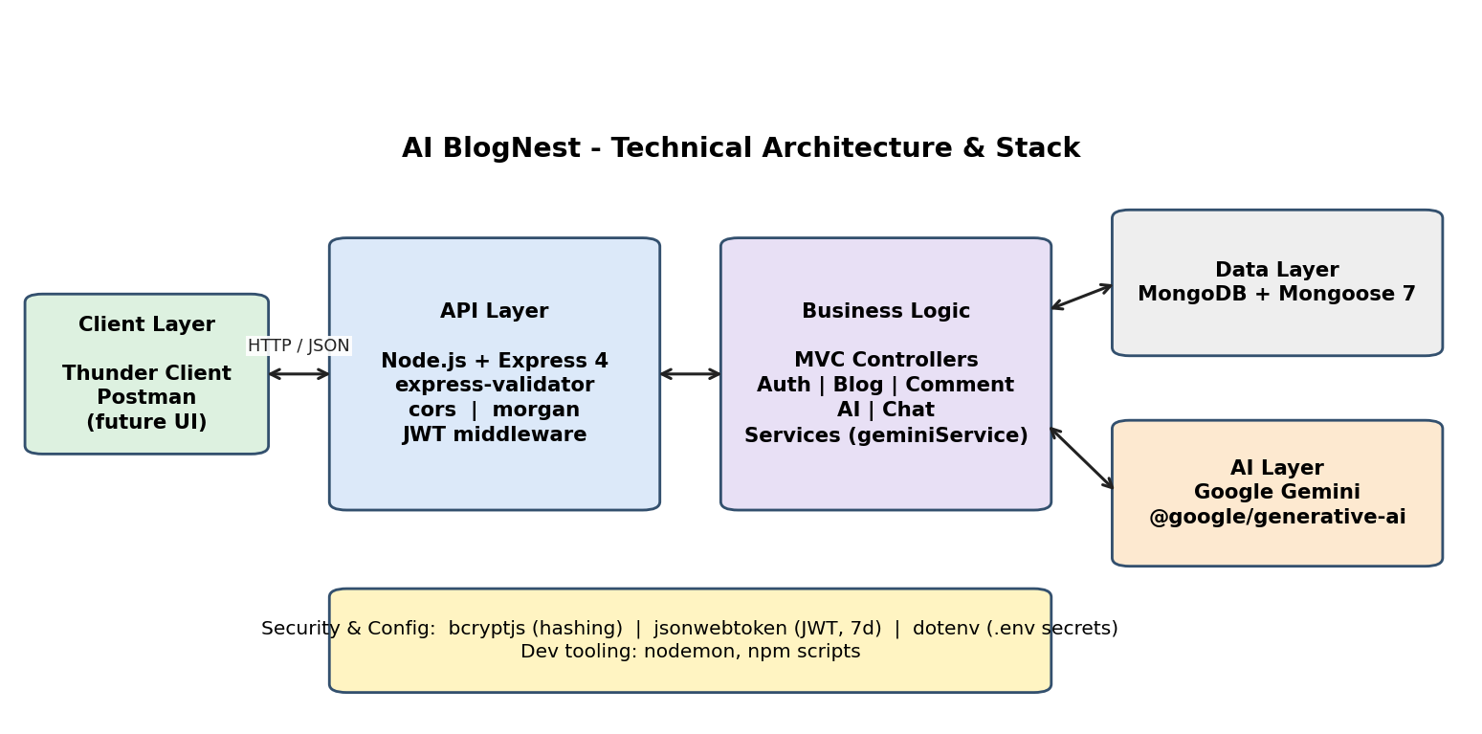
Table-1 : Components & Technologies:
S.No | Component | Description | Technology
 | User Interface | REST API consumed through Thunder Client / Postman (a web or mobile UI can be added later) | Thunder Client, Postman, JSON over HTTP
 | Application Logic-1 | Authentication, blogs and comments handled by MVC controllers, routes and middleware | Node.js, Express 4, express-validator
 | Application Logic-2 | AI logic: blog generation, summarisation and category detection using Gemini | geminiService.js, @google/generative-ai
 | Application Logic-3 | Chatbot logic: per-user chat with last 20 messages as context | chatController.js, Gemini chat session
 | Database | Collections: users, blogs, comments, chats (Mongoose schemas with timestamps) | MongoDB, Mongoose 7
 | Cloud Database | Hosted MongoDB can be used by setting MONGO_URI | MongoDB Atlas (optional)
 | File Storage | Not required. All content is stored as text in MongoDB | N/A
 | External API-1 | Generate blogs, summaries and chat replies | Google Gemini API
 | External API-2 | Not used in the current version | N/A
 | Machine Learning Model | Large language model for text generation (model set by GEMINI_MODEL) | Google Gemini
 | Infrastructure (Server / Cloud) | Local server: node src/server.js (nodemon in development), port from .env. Cloud: deployable to any Node.js host | Local, Cloud hosting (optional)

Table-2: Application Characteristics:
S.No | Characteristics | Description | Technology
 | Open-Source Frameworks | Express, Mongoose, cors, morgan, express-validator, dotenv, nodemon | Node.js ecosystem (npm)
 | Security Implementations | Password hashing, token-based access control, ownership checks, input validation, secrets in .env | bcryptjs (10 rounds), jsonwebtoken (7-day JWT), express-validator
 | Scalable Architecture | 3-tier layered MVC (routes, controllers/services, models); stateless API | Express + MongoDB
 | Availability | Stateless instances can be replicated behind a load balancer; health-check route GET / | Node.js, load balancer (deployment)
 | Performance | Chat context capped at 20 messages, short AI outputs, sorted queries, indexed user field | Mongoose indexes, prompt limits

References:
https://c4model.com/
https://developer.ibm.com/patterns/online-order-processing-system-during-pandemic/
https://www.ibm.com/cloud/architecture
https://aws.amazon.com/architecture
https://medium.com/the-internal-startup/how-to-draw-useful-technical-architecture-diagrams-2d20c9fda90d

